Section A
- Which of these is a naturally occurring polymer?
Tick ( ) one box.
- Cellulose | 
- Glucose
- Amino acids

- What is the function of DNA?
Tick ( ) one box.
- To control the movement of substances into and out of cells
- To provide genetic instructions for development and functioning
- To act as the brains of a cell

- Label the three parts that make up the structure of DNA:

- Name the term used to describe a unit containing one of each of these subunits.

_______________________________________________________________________________________________

- Explain why DNA is described as a polymer.

_______________________________________________________________________________________________
_______________________________________________________________________________________________
_______________________________________________________________________________________________

- State the complementary base pairs.

_______________________________________________________________________________________________
_______________________________________________________________________________________________

Section B
- Starch and proteins are naturally occurring polymers. State the monomers that starch and proteins are made from:
Starch: ________________________
Proteins: ______________________

- Algae are photosynthetic organisms that live in aquatic environments.

One of the products of photosynthesis is glucose.

- Name two naturally occurring polymers that are produced from glucose.
_______________________________________________________________________________________________
_______________________________________________________________________________________________

- Gas bubbles are produced when algae photosynthesise.

Name the gas produced and describe a test that could be used to identify this gas.

Gas: ________________________
Test:
_______________________________________________________________________________________________
_______________________________________________________________________________________________

- The development and function of algae is controlled by another naturally occurring polymer.

Describe the shape and structure of this polymer.

_______________________________________________________________________________________________
_______________________________________________________________________________________________
_______________________________________________________________________________________________
_______________________________________________________________________________________________
_______________________________________________________________________________________________
_______________________________________________________________________________________________
_______________________________________________________________________________________________
_______________________________________________________________________________________________
_______________________________________________________________________________________________
_______________________________________________________________________________________________

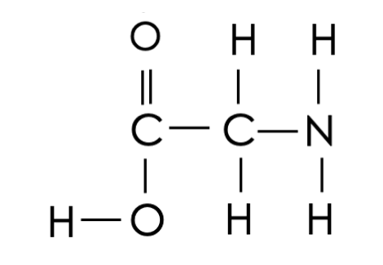
- The displayed formula below shows a molecule of glycine, an amino acid.

- How many functional groups are there in a molecule of glycine?
Tick ( ) one box.
- 1
- 2
- 3
- 4

- Molecules of glycine can react to produce a polypeptide through condensation polymerisation.

Name the other product made in this reaction.

_______________________________________________________________________________________________

Section C

- Starch is a naturally occurring polymer.
- Explain why starch is a polymer.
- Starch must be digested before it can be absorbed into the small intestine. Explain why.
- Describe and explain how the small intestine is adapted for diffusion of nutrients into the bloodstream.

